Multiple choice section

|  |  |  |  |  |  |  |  |  |
| --- | --- | --- | --- | --- | --- | --- | --- | --- |
| Question | 1 | 2 | 3 | 4 | 5 | 6 | 7 | 8 |
| Answer | A | D | A | B | A | D | B | A |

Question 1 [10.2]

A

Only a dilation changes size.

Question 2 [10.2]

D

Reflections are not translations.

Question 3 [10.2]

A

reflection

Question 4 [10.5]

D

None of the characters are symmetrical.

Question 5 [10.5]

A

Asymmetrical shapes do not have an axis of symmetry.

Question 6 [10.6]

D

Top layer = 1

2nd layer = 2

3rd layer = 4

Bottom layer = 12

1 + 2 + 4 + 12 = 19

Question 7 [10.1]

B

Opposite of left is right; opposite of up is down.

7 units left – 7 units right

2 units up – 2 units down

Question 8 [10.2]

A

A reflection produces a mirror image.

Multiple-choice total marks: 8

Short answer section

Question 9 2 marks [10.5]

(a) Objects with reflectional symmetry possess at least one axis of symmetry.

(b) When an object is translated, the image produced is the same size as the object, but it is in a different location.

Question 10 2 marks [10.5]

An axis of symmetry is a line that can be drawn through a shape such that any one side is the mirror image of the other. For example a circle cut down the middle

Question 11 2 marks [10.1]

3 units to the right

Question 12 2 marks [10.2]

(a) 90°

(b) 270°

Question 13 2 marks [10.1]

4 units left and 1 unit down

Question 14 3 marks [10.1]

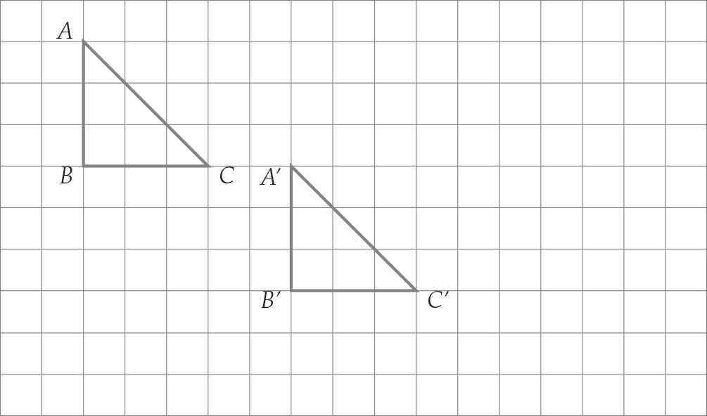

Question 15 2 marks [10.1]

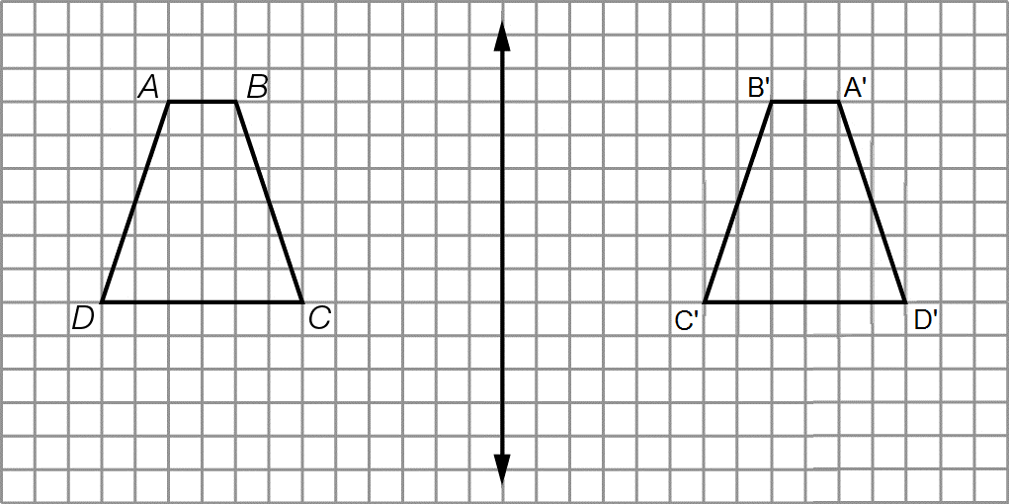

Question 16 2 marks [10.3]

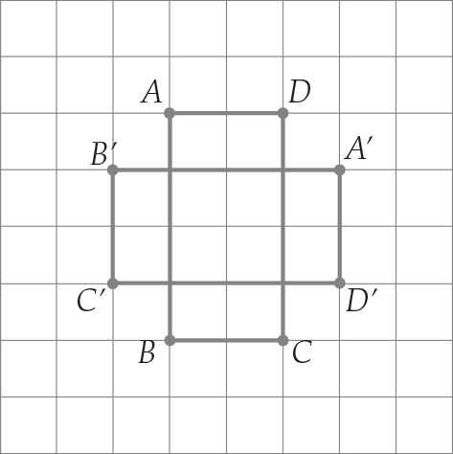

Question 17 2 marks [10.5]

(a) 1 axis of symmetry

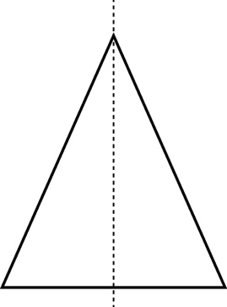

(b) 2 axes of symmetry

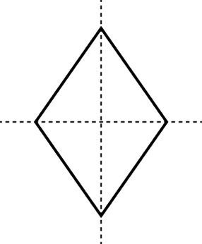

Question 18 2 marks [10.5]

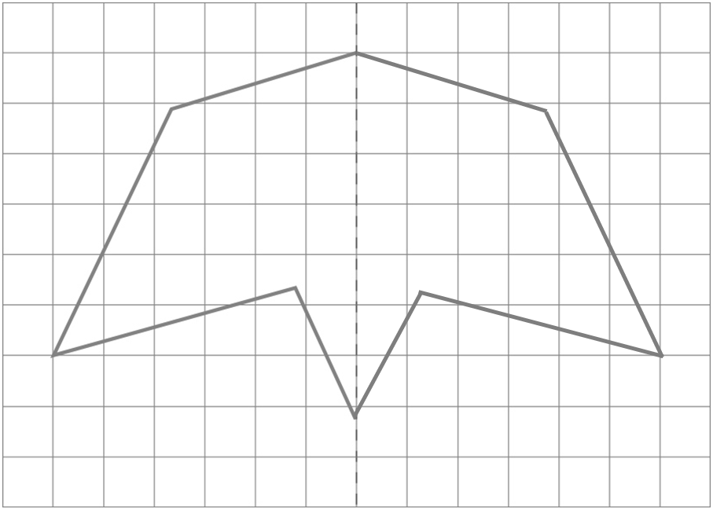

Question 19 1 marks [10.6]

Top layer = 3 cubes

Middle layer = 6

Bottom layer = 9 cubes

3 + 6 + 9 = 18 cubes

Question 20 2 marks [10.7]

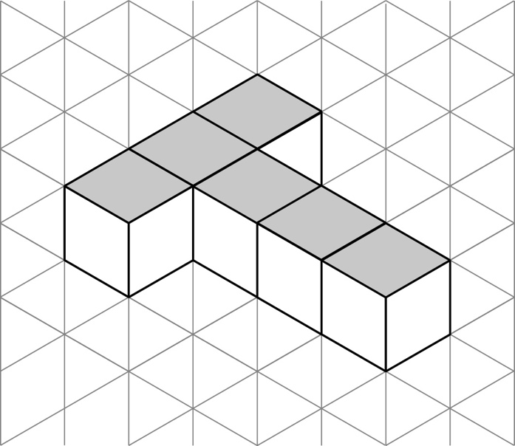

Question 21 3 marks [10.7]

|  |  |  |
| --- | --- | --- |
| (a) top view  Macintosh HD:Users:lizwaud:Desktop:PM7_eBook:Batch 1 commenced:Artwork_CORRECTED_041016_Use this:Ch10:PM2e_07_EB_10_ATS_01.jpg | (b) front view  Macintosh HD:Users:lizwaud:Desktop:PM7_eBook:Batch 1 commenced:Artwork_CORRECTED_041016_Use this:Ch10:PM2e_07_EB_10_ATS_02.jpg | (c) side view  PM7_SmB_SSa10_12a |

Question 22 4 marks [10.5]

(a)

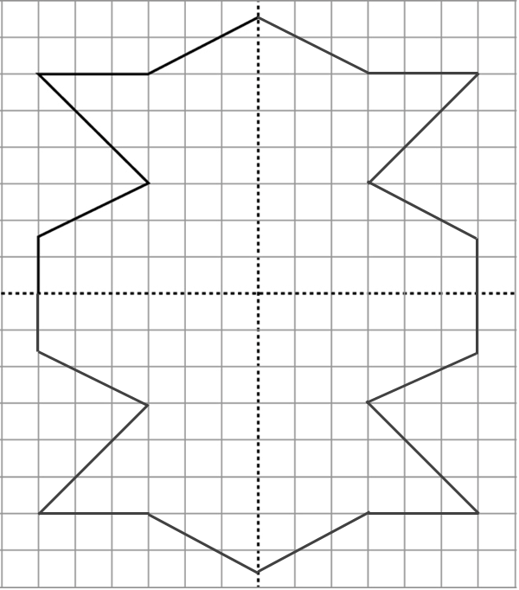

(b) This shape has reflectional and rotational symmetry

Short answer total: 31

Extended answer section

Question 23 6 marks [10.2]

(a)

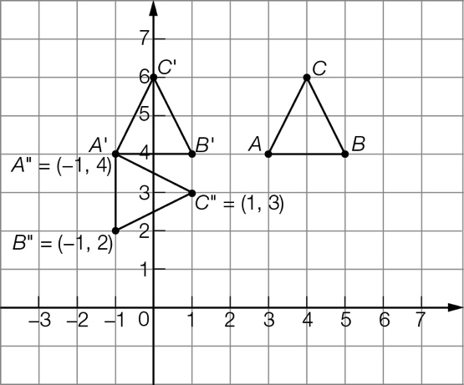

(b) A'B'C' translated image 4 units to the left

(c) A"B"C" rotated 90° clockwise around point A'

(d) Coordinates A"(-1, 4) B" (-1, 2) C" (1, 3)

Extended answer total: 6

TOTAL test marks: 45